# **Why Company Teams Need To Be Certified in AI Prompt Engineering**

In an era where artificial intelligence (AI) has become a prominent driver of innovation and competitive advantage, it is increasingly important for businesses to foster a workforce that is not only familiar with AI but can also leverage its potential effectively. One crucial component of this AI-driven future is AI Prompt Engineering, a field that focuses on designing, implementing, and managing AI prompts to optimize their functionality and usefulness.

This article explores the importance of AI Prompt Engineering certification for company teams and how it can contribute to the organization's growth and success.

## **The Dawn of AI Prompt Engineering**

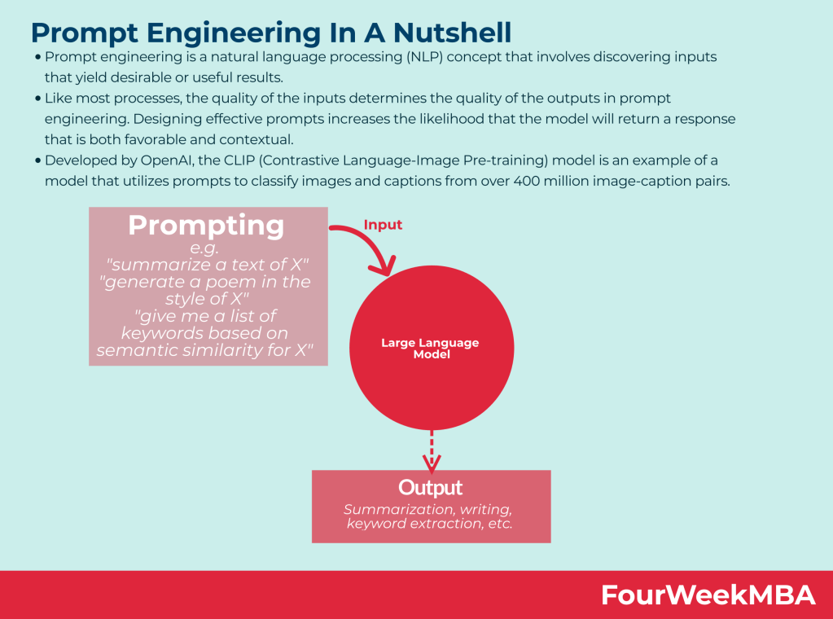

[Source](https://i0.wp.com/fourweekmba.com/wp-content/uploads/2023/01/prompt-engineering.png?resize=2048%2C1520&ssl=1)

In the realm of artificial intelligence, AI prompts serve as the critical bridge between human instruction and machine functionality. As guidelines or directives rooted in the principles of natural language processing, these prompts are what we feed into AI models, such as large language models like GPT-4, to elicit specific, desired outputs.

The role these prompts play is pivotal, acting as the compass that navigates the course of the AI models. It is through these prompts that we can guide and control the output of these sophisticated machine-learning models. Consequently, the quality, relevance, and practical usability of the AI’s output hinge significantly on the prompts it receives.

As such, the ability to master prompt engineering - the art and science of crafting and managing effective AI prompts - becomes an indispensable asset. It is a skill that can unlock the latent potential of AI technologies and harness their full power in a constructive and meaningful way.

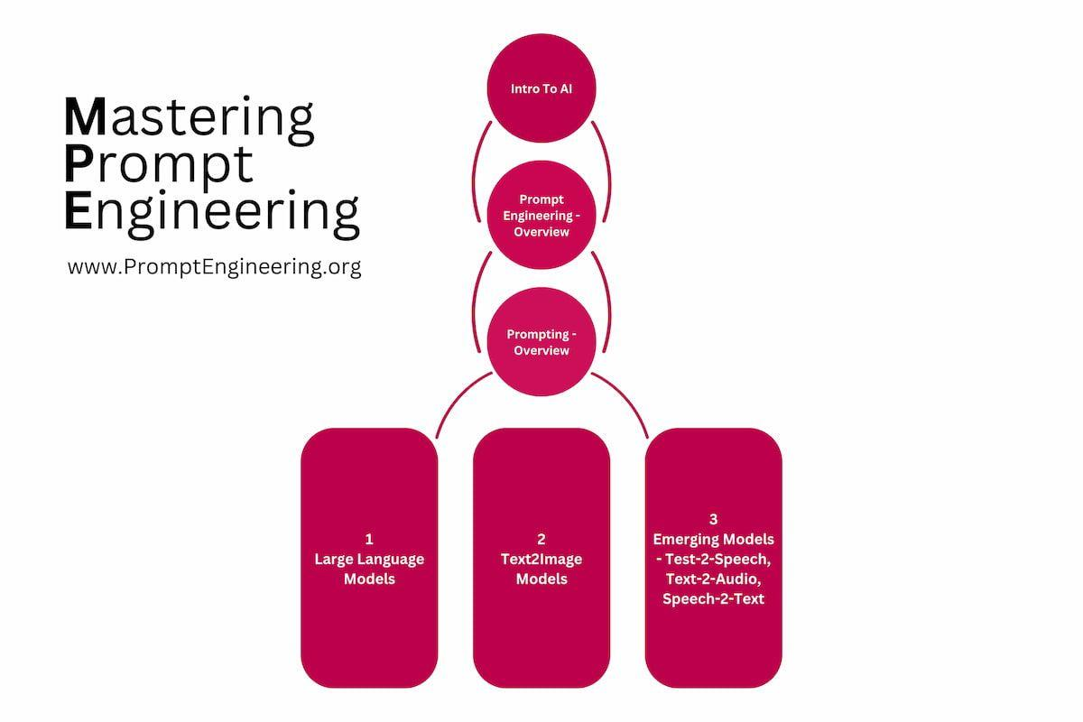

[Source](https://www.promptengineering.org/content/images/2023/03/Mastering-Prompt-Engineering-Course---prompt-engineering.org-4.jpg)

Becoming a proficient prompt engineer demands a distinctive combination of qualities and skills. It calls for technical expertise, to understand and navigate the underlying AI mechanisms and system intricacies. It requires creativity, to tailor prompts that are not only functional but also innovative and adaptive. It also entails a profound comprehension of the AI's capabilities and limitations, to exploit its strengths while circumventing its weaknesses.

## **Why AI Prompt Engineering Certifications?**

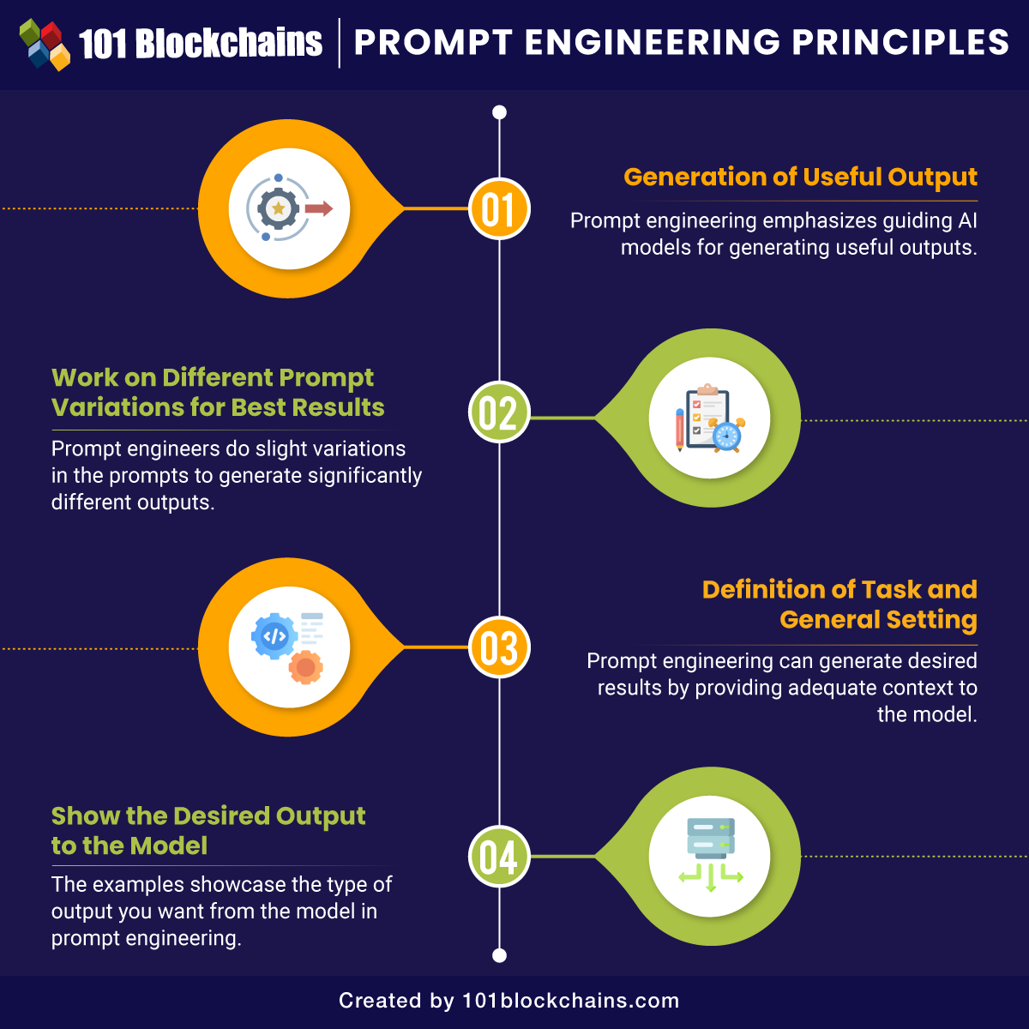

[Source](https://101blockchains.com/wp-content/uploads/2023/02/Prompt-Engineering-Principles.png)

The need for AI Prompt Engineering certifications in company teams arises from three primary areas: enhancing AI effectiveness, ensuring ethical AI use, and staying competitive in the AI-driven landscape.

### **Enhancing AI Effectiveness**

AI Prompt Engineering is the key to unlocking the full potential of AI technologies. A well-crafted prompt can guide the AI to provide useful, accurate, and context-appropriate responses. Conversely, a poorly designed prompt can lead to irrelevant or even incorrect outputs. Therefore, it is vital for teams working with AI to be proficient in prompt design and management, which a proper certification program can ensure.

Moreover, AI Prompt Engineering is not a one-size-fits-all skill. It requires a deep understanding of the specific AI model in use, as different models may respond differently to the same prompt. Certification programs provide a structured way to learn and apply these nuances, thus maximizing the effectiveness of AI applications in the business.

### **Ensuring Ethical AI Use**

As AI becomes more pervasive in businesses, ethical concerns around its use are growing. These concerns include issues of privacy, bias, transparency, and accountability. AI Prompt Engineering plays a crucial role in addressing these issues.

For instance, prompts can be designed to guide the AI toward unbiased and fair outputs. Similarly, prompts can also be used to ensure the AI respects user privacy by avoiding certain types of information in its responses. By certifying teams in AI Prompt Engineering, businesses can ensure their AI applications are not just effective, but also ethical.

### **Staying Competitive in the AI-Driven Landscape**

In the fast-paced, AI-driven business landscape, staying competitive means staying ahead in AI adoption and utilization. Companies need to be not just users of AI, but innovators and leaders in the field. AI Prompt Engineering certification provides teams with the skills and knowledge to push the boundaries of what's possible with AI, thus giving businesses a competitive edge.

In addition, as more businesses adopt AI, there's a growing demand for professionals skilled in AI Prompt Engineering. By certifying their teams, businesses can attract and retain top talent in the field, further enhancing their competitive advantage.

### **Expanding Expertise and Standardizing Skills**

AI Prompt Engineering is a specialized skill set that forms the core of effective interaction with AI models. However, the field is evolving rapidly, and staying current requires continuous learning and development. Certification programs offer an organized and structured method for professionals to expand their knowledge base and stay up-to-date with the latest advancements in AI technologies.

Moreover, certification programs provide a benchmark of competency, allowing companies to ensure that their teams have a standardized set of skills. This not only ensures a minimum level of proficiency but also aids in identifying knowledge gaps that need to be addressed.

### **Cultivating a Stronger Workforce**

AI Prompt Engineering Certification programs, in their unique design, frequently blend theoretical knowledge with hands-on, practical training. Participants don't just learn about AI Prompt Engineering in the abstract; they roll up their sleeves and delve into the practical aspects of crafting and managing AI prompts. This immersive training methodology allows learners to internalize the nuances of the subject matter deeply, bridging the gap between conceptual understanding and tangible application.

Such practical, hands-on training experiences have a transformative effect on the learners. It's not just about gaining new knowledge; it's about integrating that knowledge into their problem-solving toolkit. Participants, through practice, gain the confidence and expertise to handle complex AI-related tasks, enhancing their professional prowess significantly. This kind of learning experience, where skills are honed through practice, is instrumental in fostering a workforce that's not just knowledgeable but also highly efficient in executing AI-related tasks.

Importantly, this proficiency in AI Prompt Engineering has far-reaching implications for an organization's overall performance. A team that can effectively navigate the complexities of AI prompts can better harness the power of AI technologies, unlocking new levels of efficiency and innovation. This enhanced ability to utilize AI tools results in a productivity boost across various functions within the organization.

### **Mitigating Risks and Limitations**

Despite the tremendous power and potential of artificial intelligence, it's not an infallible technology. It comes with its own set of limitations and challenges that can surface in various forms. Missteps in the utilization of AI can yield a host of complications. These can span from the generation of inaccurate and unreliable results, which can compromise decision-making and operational efficiency, to more profound concerns like ethical dilemmas that can impact reputation and stakeholder trust.

This inherent complexity and the potential for unintended consequences underscore the need for comprehensive training, such as the kind offered through AI Prompt Engineering Certification programs. These programs equip teams with the necessary tools and insights to navigate the intricacies of AI usage effectively, ensuring that its deployment is beneficial rather than detrimental.

One of the main ways this is achieved is through fostering a deep understanding of how to design and manage AI prompts proficiently. The prompts fed into an AI model significantly influence the output. Therefore, the ability to craft effective prompts, tailored to the specific requirements of the task at hand, is a crucial skill. It can greatly enhance the accuracy and relevance of the AI's output, mitigating the risk of erroneous results.

Certification programs also provide training on how to manage AI outputs effectively. This involves interpreting the results correctly, validating their accuracy, and knowing how to adjust the prompts or the AI model's settings to fine-tune the outputs as required.

Furthermore, these programs also prepare participants to handle potential issues that might arise during the usage of AI. This includes technical glitches, unexpected outputs, or ethical concerns. The ability to anticipate, identify, and resolve these issues is a critical competency in ensuring the responsible and beneficial deployment of AI technologies.

### **Fostering Innovation**

AI Prompt Engineering Certification plays an instrumental role in promoting and fostering innovation. It does this by providing a comprehensive understanding of AI systems, their operational nuances, and their capabilities. This intimate knowledge equips teams with the tools they need to explore the limits of AI technologies and potentially expand those boundaries.

The mastery of AI systems through certification allows teams to think beyond the conventional uses of AI. They are empowered to experiment with novel approaches and methodologies, fueled by a deep understanding of the underpinnings of AI technologies. This exploratory mindset can lead to unexpected insights and the development of innovative applications for AI, pushing the envelope of what is currently deemed possible.

The capacity to develop new uses for AI in various work contexts is another valuable byproduct of AI Prompt Engineering Certification. By understanding the full spectrum of AI capabilities, teams can identify opportunities to integrate AI technologies in their work processes in innovative ways. This can lead to increased efficiency, the discovery of novel solutions to existing problems, and the opening up of new avenues for exploration and growth.

Moreover, teams equipped with AI Prompt Engineering Certification are not just passive consumers of AI technologies; they can actively contribute to their evolution. The insights gained from their experimentation and application of AI can feed back into the broader AI community, informing the development of future AI models and algorithms. This iterative process of learning, applying, and contributing is at the heart of the dynamism and rapid progress characteristic of the AI field.

## **The Value of AI Prompt Engineering Certifications**

AI Prompt Engineering certification equips company teams with the ability to leverage AI technologies effectively and ethically, thereby leading to significant benefits in practice.

Take, for instance, the customer service sector, a field that significantly benefits from the application of AI technologies. A team that has been certified in AI Prompt Engineering can utilize its expertise to craft AI chatbots that are highly efficient and responsive. These AI-driven customer service agents, guided by well-crafted prompts, can understand and respond to customer inquiries with a high degree of accuracy. The result? Improved customer satisfaction owing to the prompt and precise resolution of queries, and reduced response times due to the ability of AI chatbots to handle multiple interactions concurrently. This can translate into enhanced customer loyalty and a more robust brand reputation.

Consider also the domain of data analysis, where vast amounts of data are processed and interpreted daily. In this data-rich environment, teams certified in AI Prompt Engineering can prove invaluable. They can guide AI models to sift through these extensive datasets, effectively and efficiently extracting valuable insights that might otherwise remain hidden. This ability to leverage AI for data analysis can significantly streamline decision-making processes, making them more informed and precise. Moreover, it can enhance strategic planning, providing a strong data-driven foundation for business strategies and initiatives.

The influence of AI Prompt Engineering certification extends even to creative fields such as advertising and content creation. Here, the blend of creativity and technical proficiency that a certified team brings can revolutionize the content creation process. They can leverage AI to generate content that's not only engaging but also finely tailored to resonate with specific audiences. Whether it's creating persuasive ad copies or compelling blog posts, AI can be guided to produce content that aligns perfectly with the target audience's preferences and interests. This personalized approach to content creation can significantly enhance audience engagement, making the content more impactful and effective in achieving its intended goals.

Lastly, in fields like cybersecurity, certified teams can harness AI to detect and prevent threats more effectively, thereby increasing the organization's security posture.

## **How Can Companies Encourage Certifications for Employees?**

Given the importance and benefits of AI Prompt Engineering certification, businesses should encourage and facilitate their teams to obtain this certification.

Firstly, businesses can provide training programs in AI Prompt Engineering, either in-house or in collaboration with reputable external providers. These programs should cover not just the technical aspects of prompt design and management, but also the ethical considerations of AI use.

Secondly, businesses can provide incentives for obtaining the certification, such as career advancement opportunities or financial rewards. This can motivate employees to acquire and improve their AI Prompt Engineering skills.

Lastly, businesses can foster a culture of continuous learning and innovation. This includes promoting the sharing of knowledge and experiences among team members, encouraging experimentation with AI prompts, and celebrating successes in AI use.

As AI continues to redefine the business landscape, AI Prompt Engineering has emerged as a crucial skill for harnessing the power of AI technologies effectively and ethically. By certifying their teams in becoming AI prompt engineers, businesses can enhance their AI effectiveness, ensure ethical AI use, and stay competitive in the AI-driven landscape. Moreover, they can realize significant benefits in practice, from improving customer service to enhancing decision-making to boosting cybersecurity. Therefore, AI Prompt Engineering certification is not just a nice-to-have, but a must-have for company teams in the AI era.